**Lab 6: Updating and Deleting Records**

**1. Update a Product:**

var product = await context.Products.FirstOrDefaultAsync(p => p.Name == "Lapt

op");

if (product != null) {

product.Price = 70000;

await context.SaveChangesAsync();

}

var product = await context.Products.FirstOrDefaultAsync(p => p.Name == "Laptop");

if (product != null)

{

    product.Price = 70000;

    await context.SaveChangesAsync();

    Console.WriteLine("Product updated: Laptop price changed to ₹70000");

}

else

{

    Console.WriteLine("Laptop not found.");

}

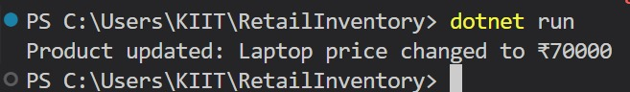

**2. Delete a Product:**

var toDelete = await context.Products.FirstOrDefaultAsync(p => p.Name == "Rice

Bag");

if (toDelete != null) {

context.Products.Remove(toDelete);

await context.SaveChangesAsync();

}

// 2. Delete a Product (Rice Bag)

var toDelete = await context.Products.FirstOrDefaultAsync(p => p.Name == "Rice Bag");

if (toDelete != null)

{

    context.Products.Remove(toDelete);

    await context.SaveChangesAsync();

    Console.WriteLine("Product deleted: Rice Bag");

}

else

{

    Console.WriteLine("Rice Bag not found.");

}

